This is the thirty-ninth day of the Software 1 Eight Week Challenge, and the fourth day of your sixth week.

Your assignment is to:

1. Program in the following problem and look at the results for it and variations on it:

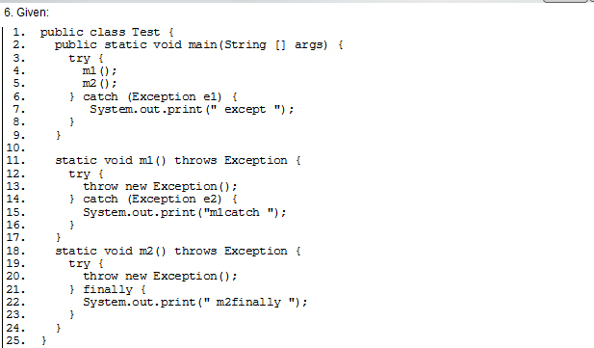

1. Program Sierra and Bates Exercise 6-1 (p.310), 6-2(p.333), 6-3 (p.341) and 6-4 (p.353).